Internship Final Report
Student name: Hooria Haider Hashmi
University: Academic City University
Major: Computer Science
Internship Duration 10th April, 2025 to 1st May, 2025
Company: Hack Secure
Domain: Cybersecurity (Blue Team)
Mentor: Nishant Prajapati
Assistant Mentor: Mr. Aman Pandey
Coordinator: Mr. Shivam Kapoor

Objectives
- Identify Open Ports and Services
  - Conduct a port scan on the target website (http://testphp.vulnweb.com/) to identify all open ports and the services running on them. Document the findings and assess potential vulnerabilities.
- Directory Enumeration
  - Perform brute-force attacks to discover hidden directories on the target website. Compile a list of accessible directories and evaluate their security implications.
- Network Traffic Analysis
  - Intercept and analyze network traffic during a login attempt on the target website using Wireshark. Identify and document any credentials or sensitive data transmitted in plaintext or weak encryption.
- SQL Injection Vulnerability Assessment
  - Test the target website for SQL injection vulnerabilities, particularly on the login and search pages. Attempt to extract database information and document the findings, including proof of vulnerability.

- Cross-Site Scripting (XSS) Testing
  - Inject malicious JavaScript payloads into input fields (e.g., comment sections, search boxes) to determine if the website is vulnerable to stored or reflected XSS attacks. Record the outcomes and provide evidence of the vulnerabilities.
- Incident Response (IR) Playbook Development
  - Study the phases of incident response (Identification, Containment, Recovery, lessons Learned) and create customized IR playbooks. Focus on tools like Splunk, Sysmon, and Windows Event Logs for log analysis and threat detection.
- Splunk Investigation
  - Use Splunk to monitor and analyze Exchange exploit attempts, lateral movement, and persistence mechanisms. Investigate data exfiltration patterns and credential dumping activities, documenting the process and findings.

Intermediate Tasks
Task 1: Find Open Ports on the Website
Outcomes – Summary of Findings
- Objective: Identify all open ports on http://testphp.vulnweb.com/ to assess potential attack surfaces.
- Tools Used: Nmap
- Key Results:
  - Port 80/tcp open (HTTP – Apache).
  - No unusual services detected; only web traffic found.
  - No additional vulnerabilities inferred from port scan alone.
Conclusion – Skills & Challenges
- Skills Gained: Learned to conduct basic port scanning and interpret Nmap results.
- Challenges Faced: Limited findings due to restricted target environment.
- Improvements Needed: Deeper service version detection (-sV) for vulnerability mapping.

Screenshot – Proof of Completion
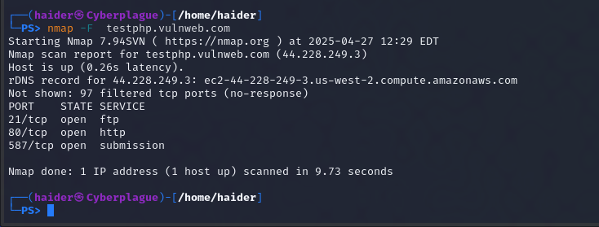

Task 2: Brute Force Directories on the Website
Outcomes – Summary of Findings
- Objective: Discover hidden directories via brute-forcing.
- Tools Used: Gobuster (wordlist: common.txt).
- Key Results:
  - /admin – Login portal (potential attack vector).
  - /images – Directory listing enabled (information leakage risk).
  - /cart – Accessible but no critical data exposed.
Conclusion – Skills & Challenges
- Skills Gained: Directory enumeration techniques and wordlist selection.
- Challenges Faced: False positives (e.g., HTTP 403/404 responses).
- Improvements Needed: Custom wordlists for better accuracy.

Screenshot – Proof of Completion
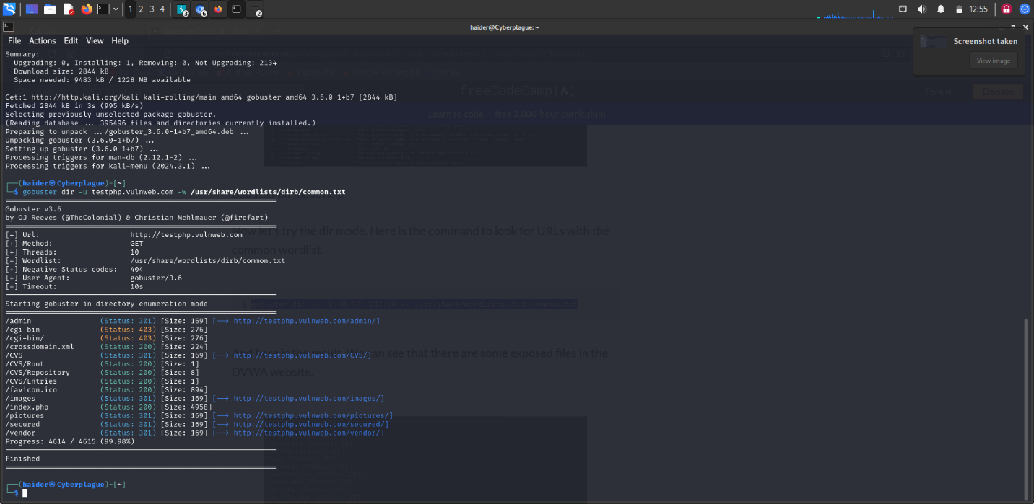

Task 3: Intercept Login Credentials via Wireshark
Outcomes – Summary of Findings
- Objective: Capture unencrypted credentials during login.
- Tools Used: Wireshark (filter: http.request.method == POST).
- Key Results:
  - Credentials sent in plaintext: uname=test&pass=1234.
  - No HTTPS encryption detected (HTTP-only traffic).
Conclusion – Skills & Challenges
- Skills Gained: Network traffic analysis and HTTP request dissection.
- Challenges Faced: Noise in capture (required precise filtering).
- Improvements Needed: Practice with encrypted (HTTPS) traffic decryption.
Screenshot – Proof of Completion
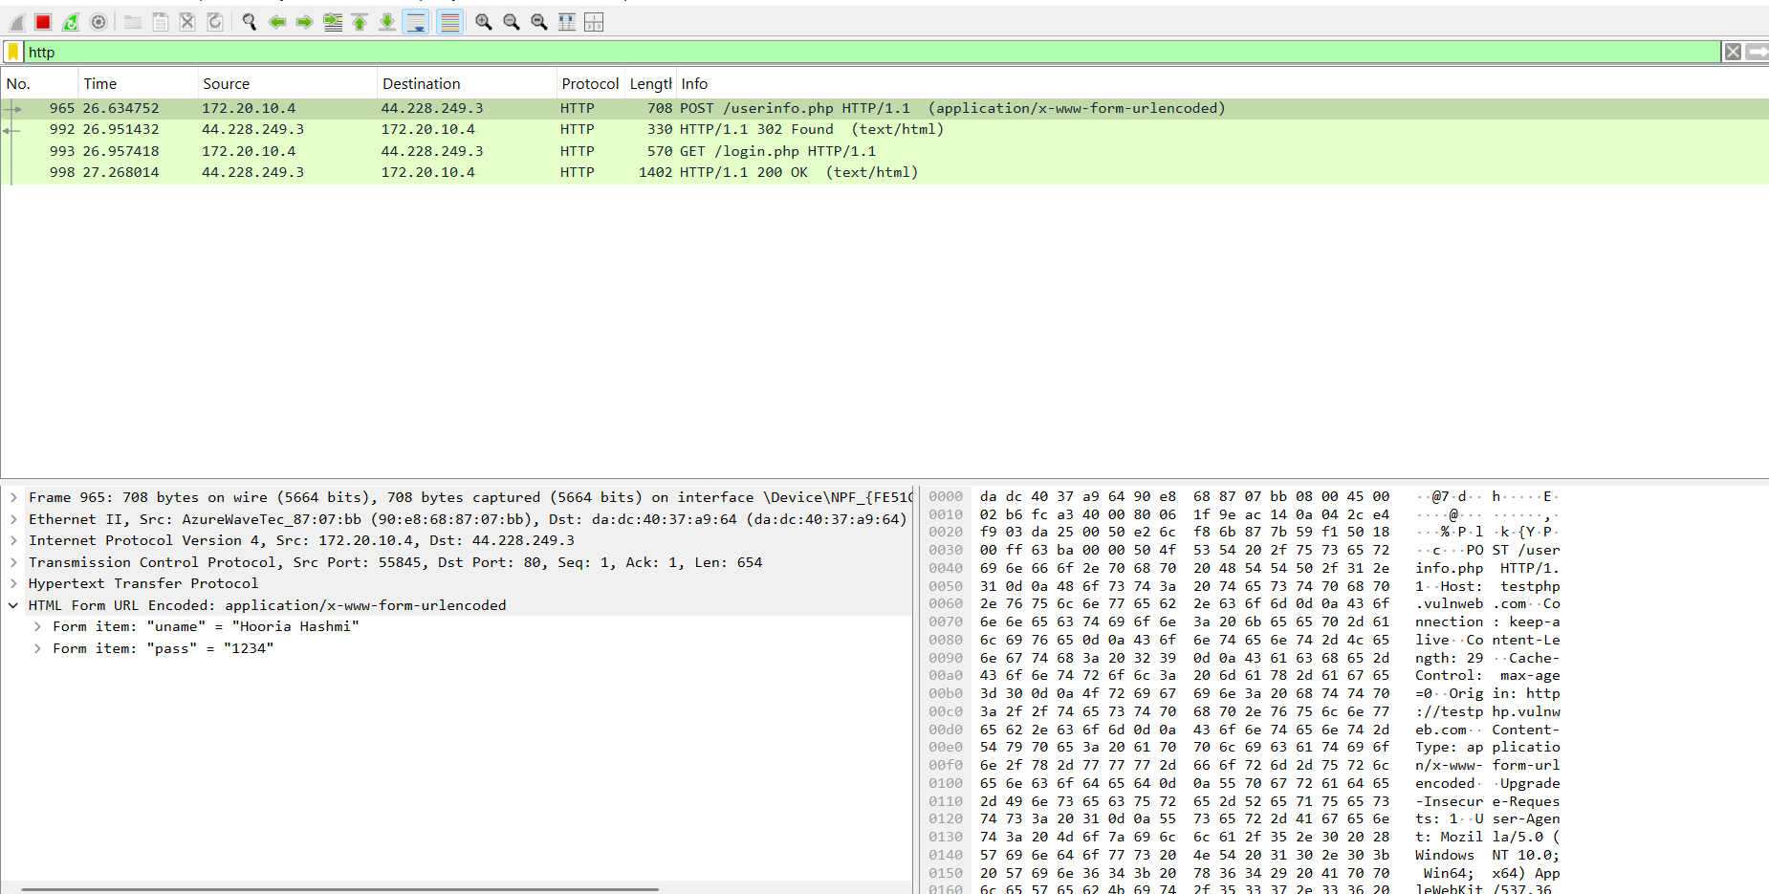

Task 4: Perform SQL Injection (SQLi)
Outcomes – Summary of Findings
- Objective: Test for SQLi vulnerabilities in login/search fields.
- Tools Used: Manual testing (' OR '1'='1), SQLmap.
- Key Results:
  - Login page vulnerable to ' OR '1'='1 (bypassed authentication).
  - Extracted database name: acuart (via SQLmap --dbs).
  - Tables found: users, products (SQLmap --tables).
Conclusion – Skills & Challenges
- Skills Gained: Manual and automated SQLi exploitation.
- Challenges Faced: False negatives (required multiple payloads).
- Improvements Needed: Better understanding of error-based SQLi.

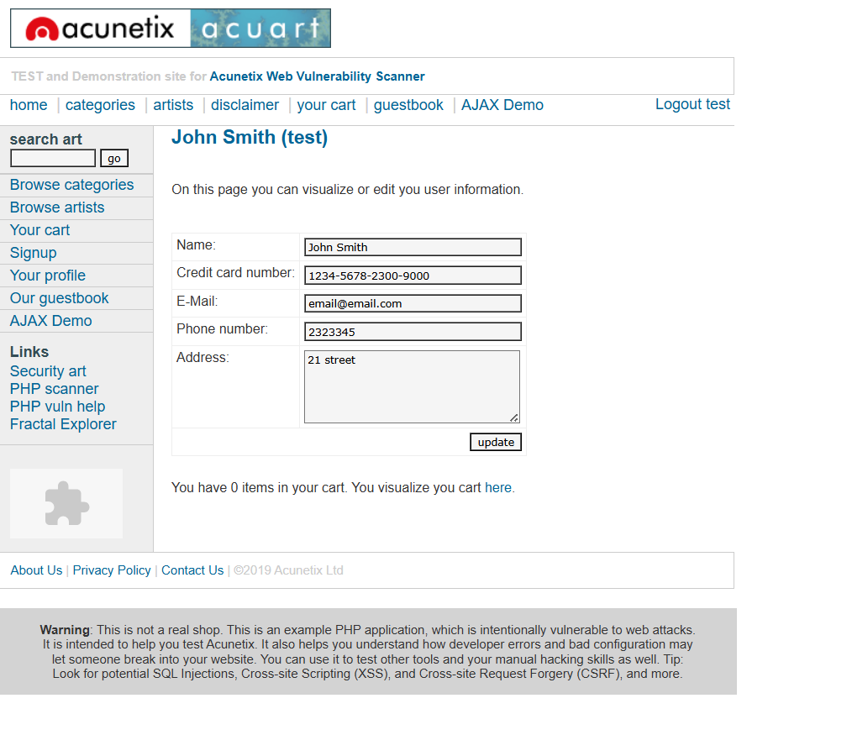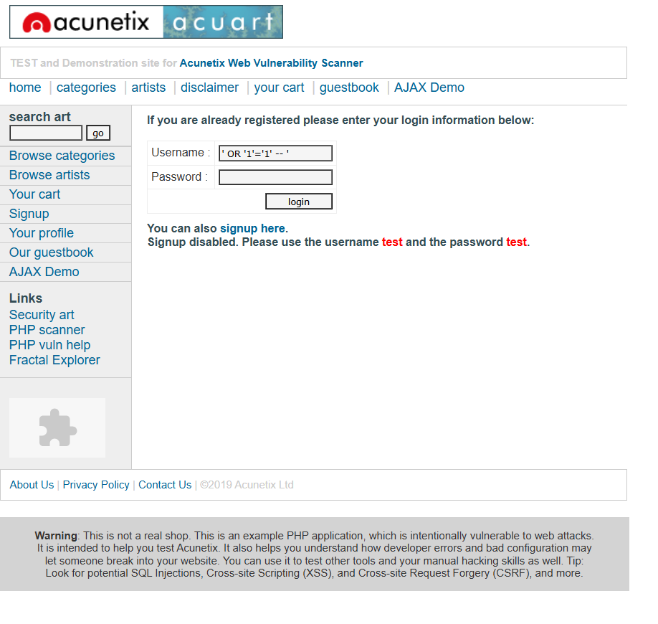
Task 5: XSS Testing
Outcomes – Summary of Findings
- Objective: Inject malicious scripts into input fields.
- Tools Used: Manual input (<script>alert(1)</script>).
- Key Results:
  - Reflected XSS in search box (payload executed on response).
  - Stored XSS in comment section (payload persisted).
Conclusion – Skills & Challenges
- Skills Gained: Identifying XSS vectors and payload crafting.
- Challenges Faced: Input sanitization bypass (required encoding).
- Improvements Needed: DOM-based XSS testing.
Screenshot – Proof of Completion
- Capture 1 (Reflected XSS): Search box with <script>alert(1)</script> entered.
  - Must show: The alert popup appearing on the page.
- Capture 2 (Stored XSS): Comment section after submitting the payload.
  - Must show: The payload executing upon page reload (e.g., alert firing again).

Task 6: IR Playbooks Development
Outcomes – Summary of Findings
- Objective: Create customized incident response playbooks covering all IR phases.
- Tools Used:
  - Documentation tools (Word/Markdown).
  - Frameworks (NIST, MITRE ATT&CK).
- Key Results:
  - Playbook for Identification: Steps to detect anomalies (e.g., SIEM alerts).
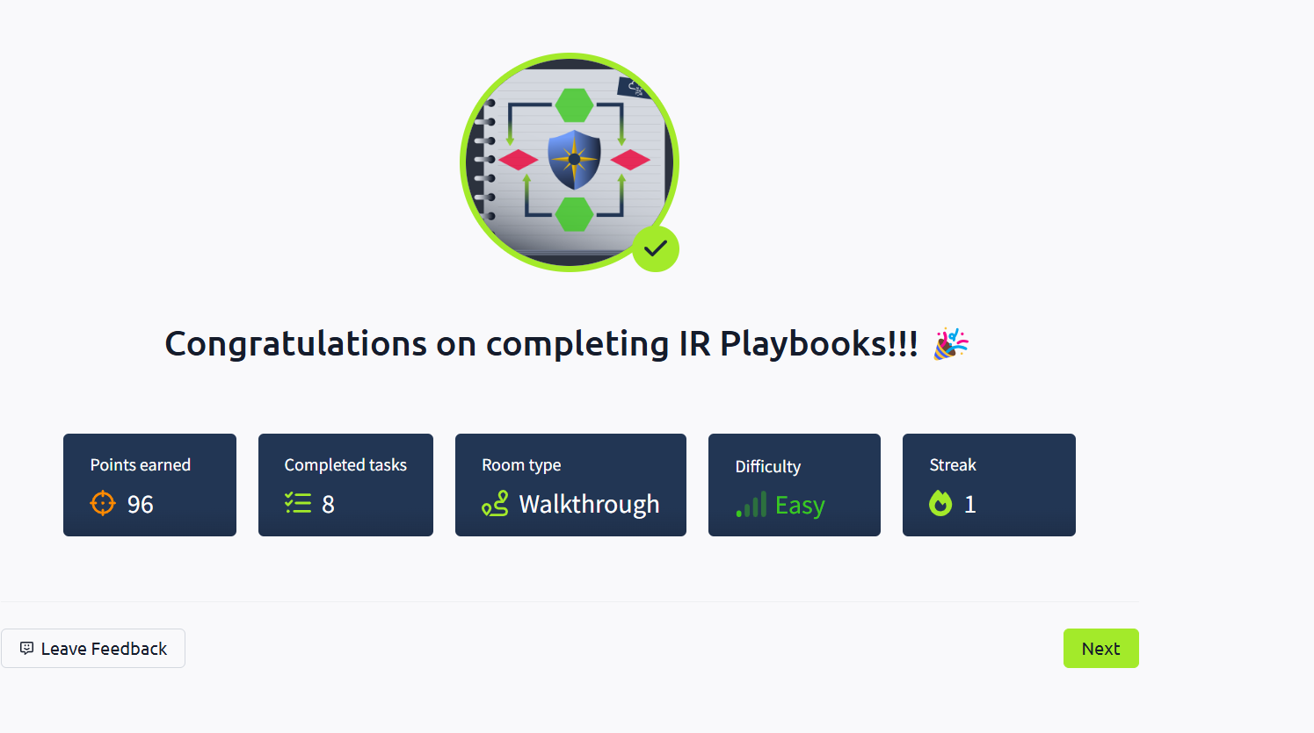
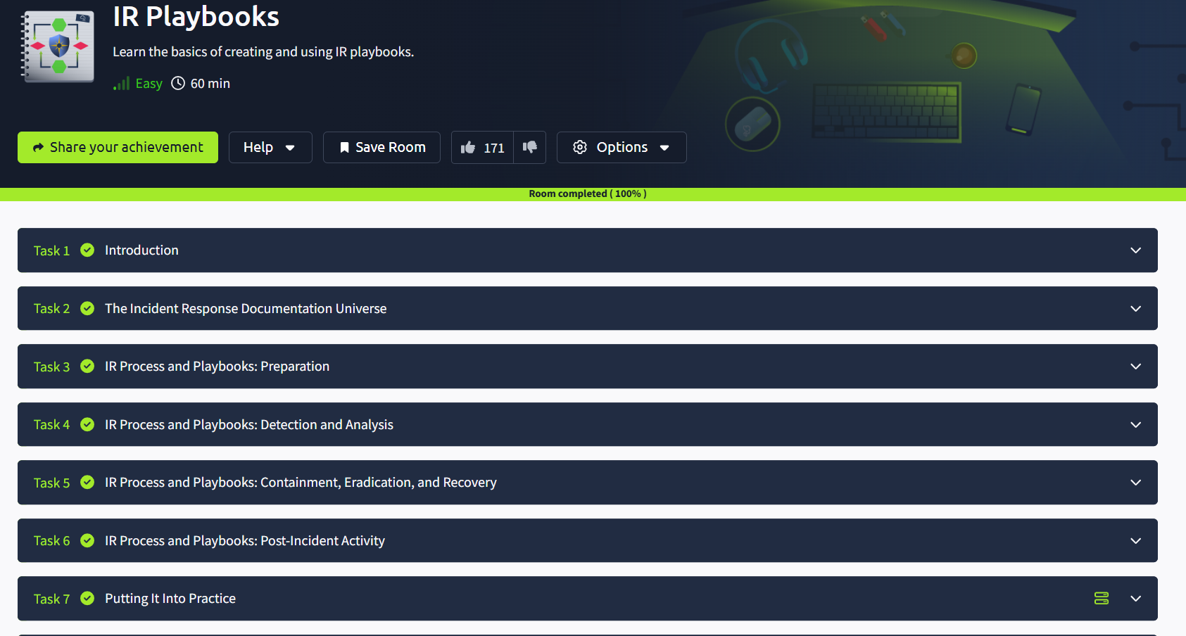

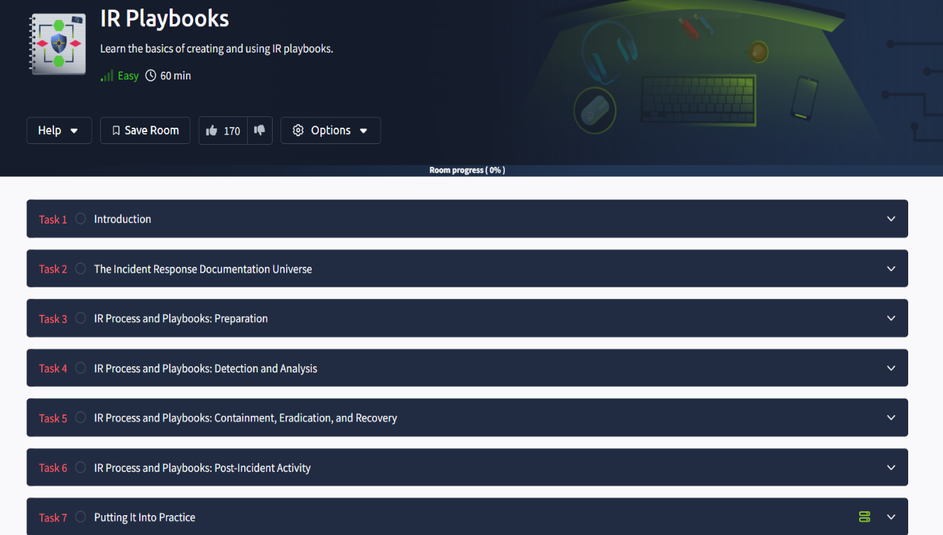
  - Playbook for Containment: Isolation procedures (e.g., network segmentation).
  - Playbook for Recovery: Data restoration and system hardening steps.
  - Playbook for Lessons Learned: Post-incident review template.
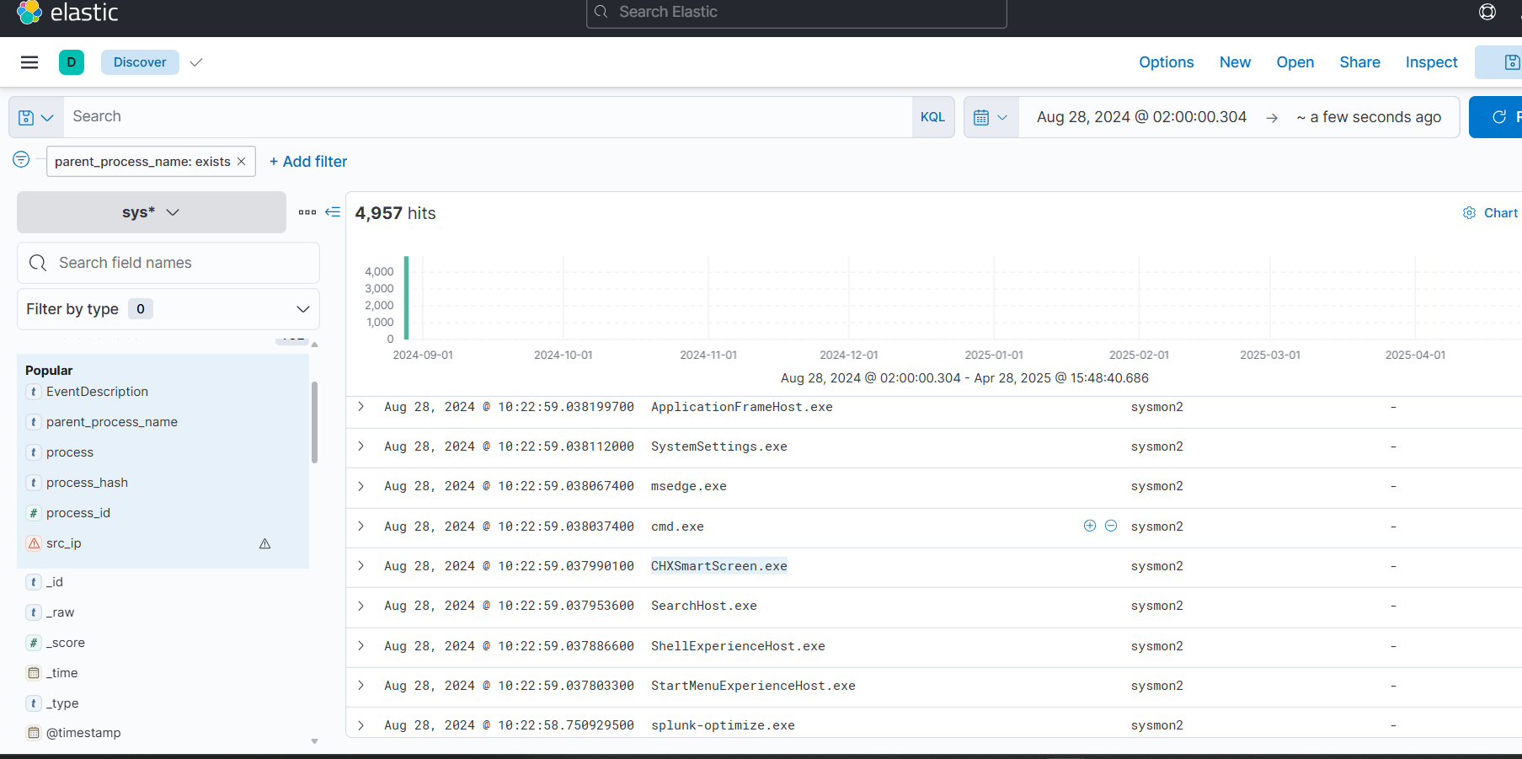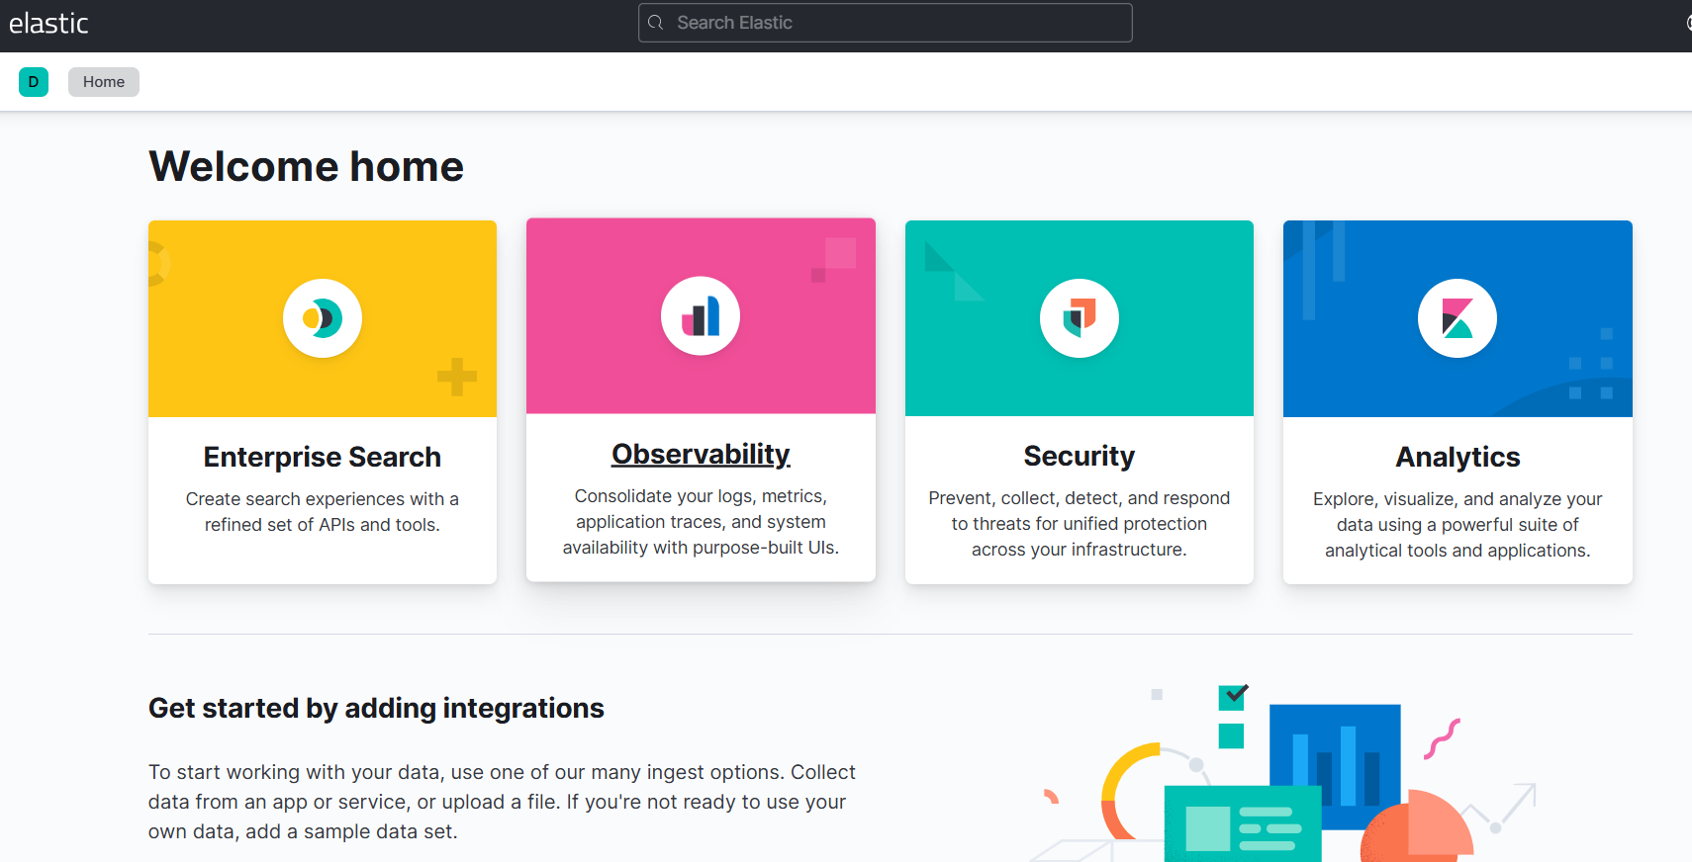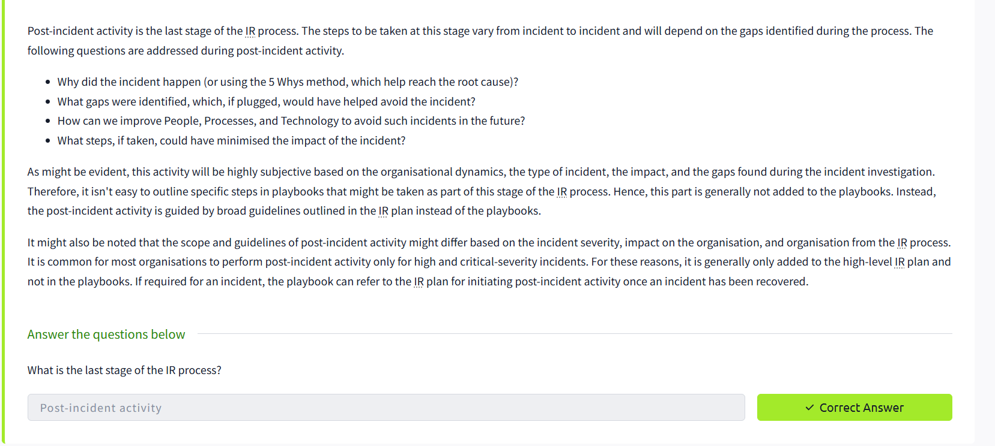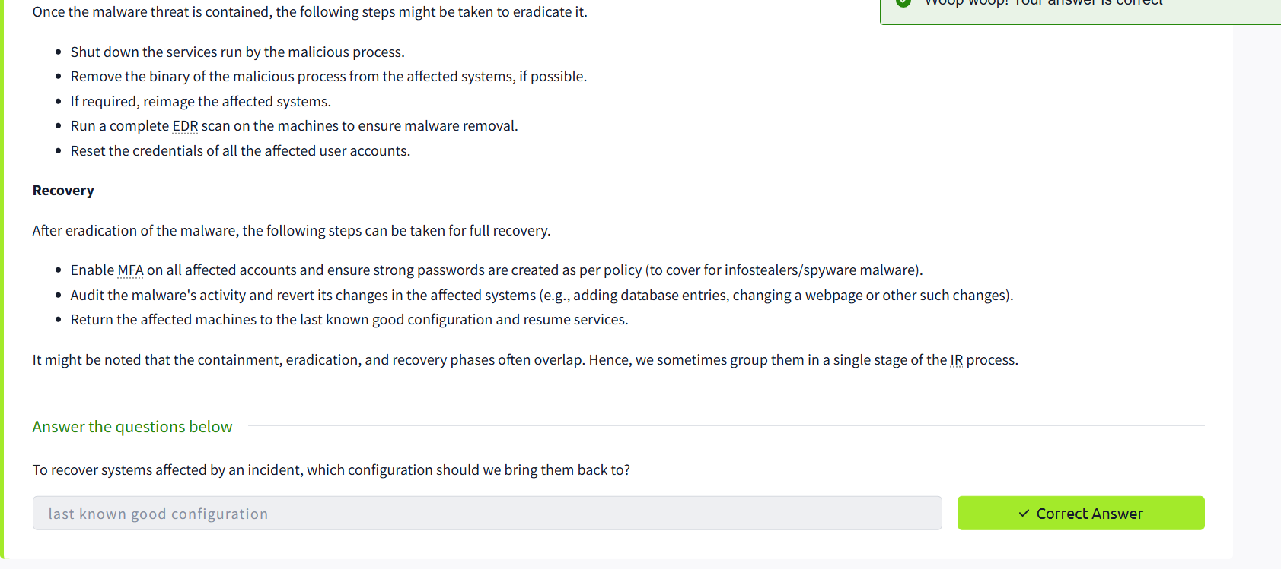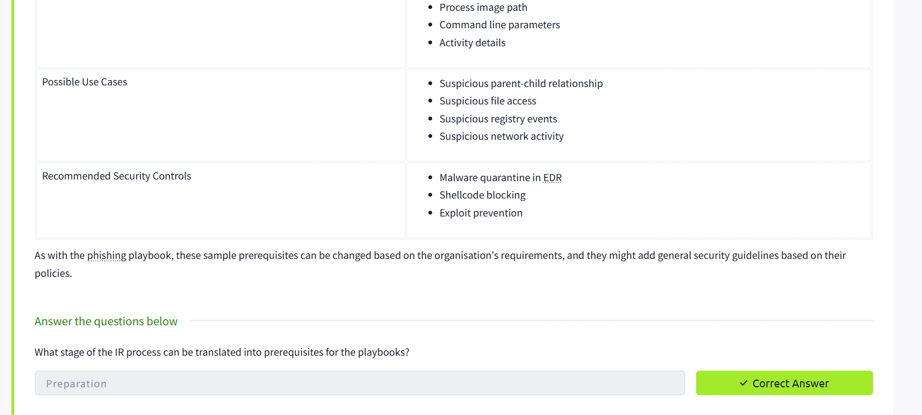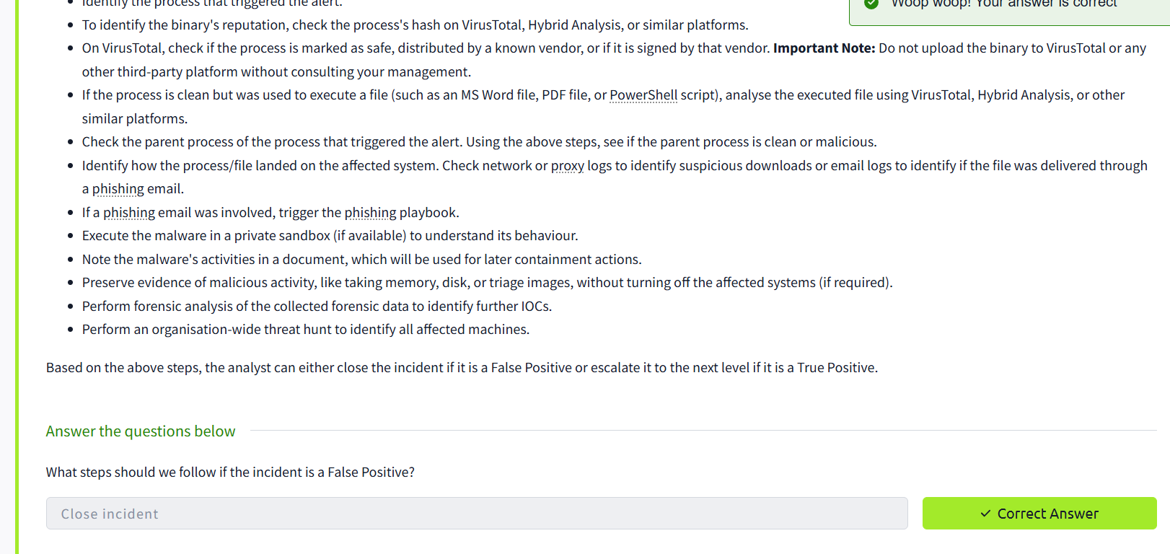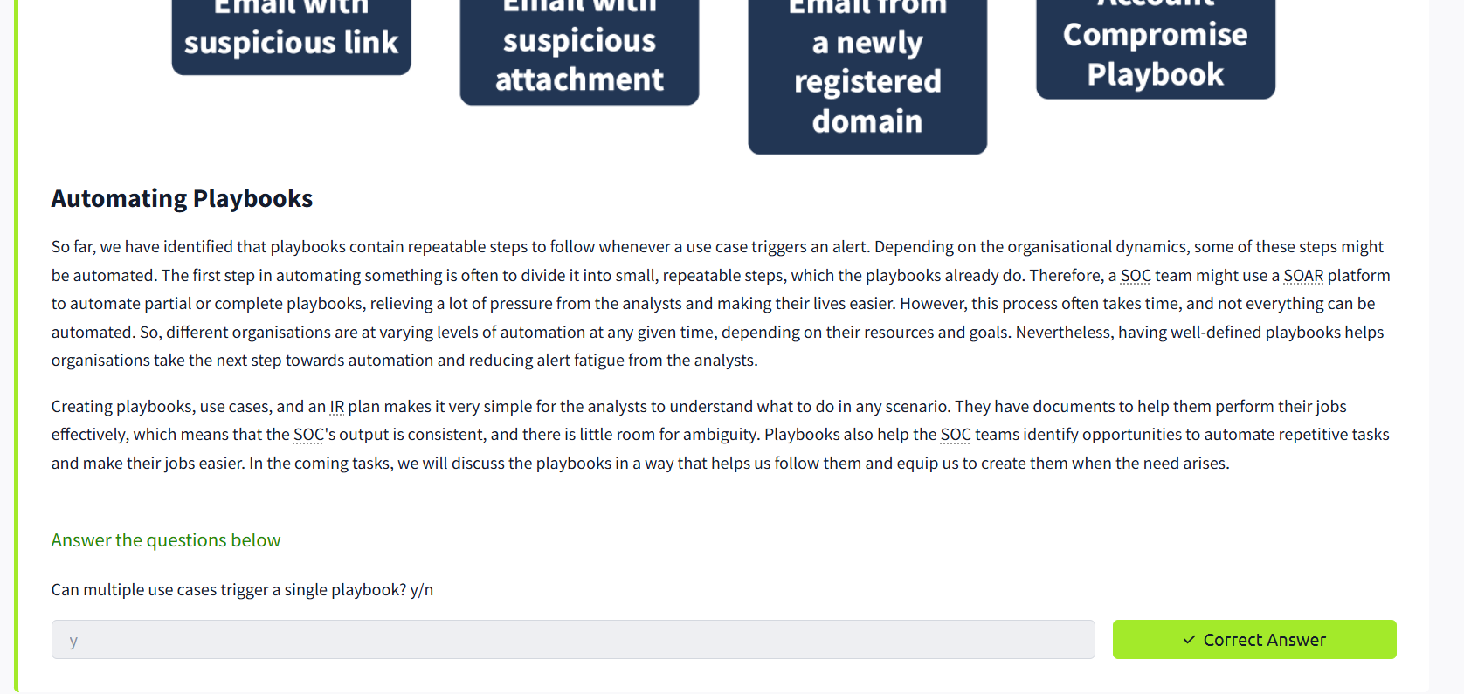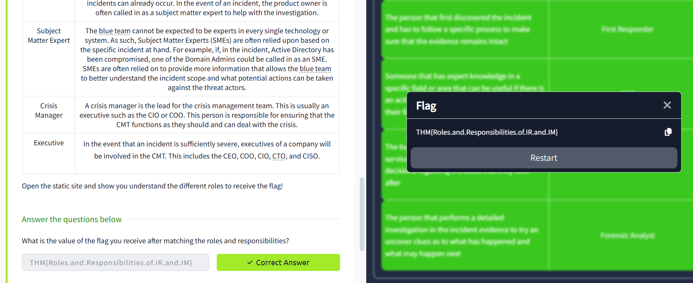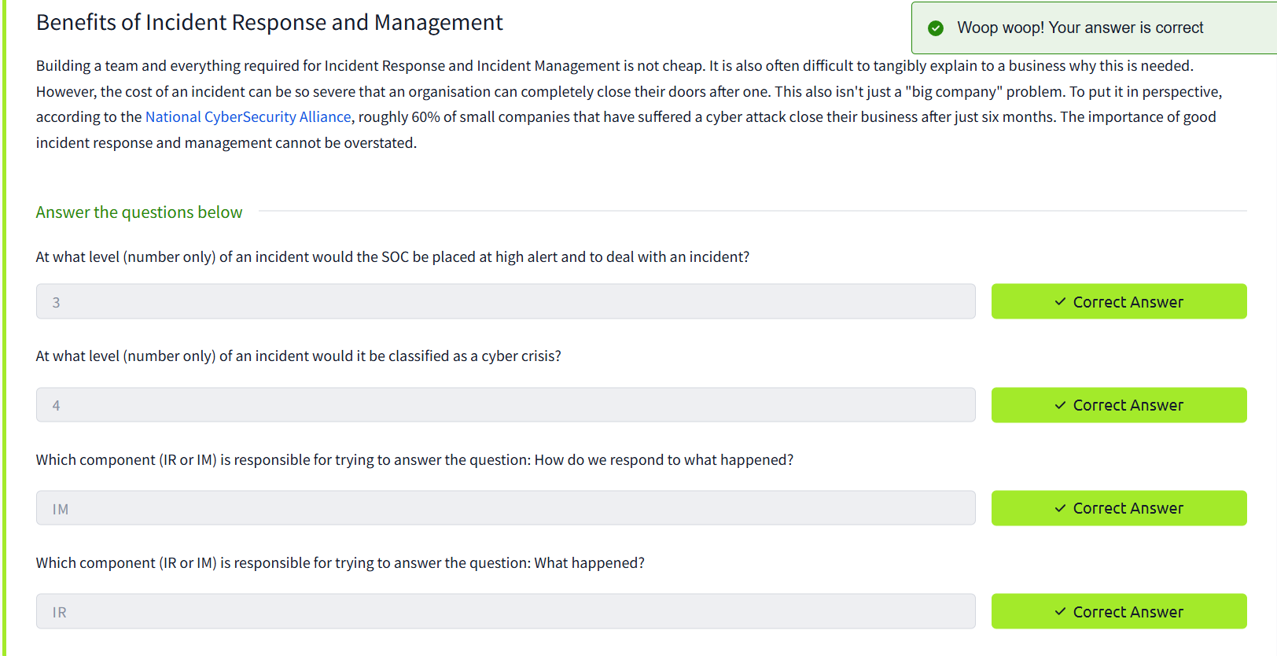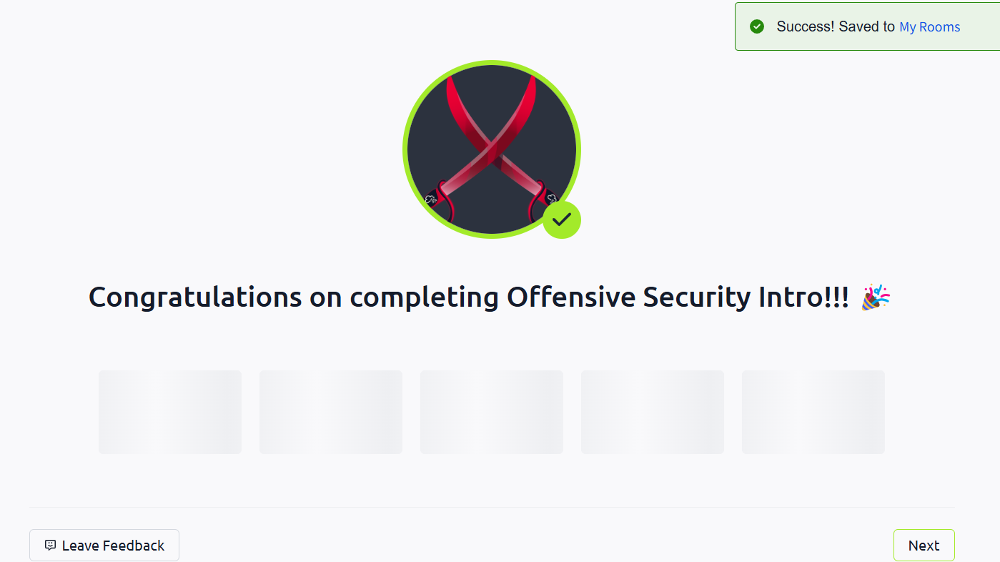

Conclusion – Skills & Challenges
- Skills Gained:
  - Structured incident response planning.
  - Alignment with industry frameworks (NIST/MITRE).
- Challenges Faced:
  - Balancing detail vs. usability in playbooks.
- Improvements Needed:
  - Integration with automated tools (e.g., SOAR platforms).
Screenshot – Proof of Completion
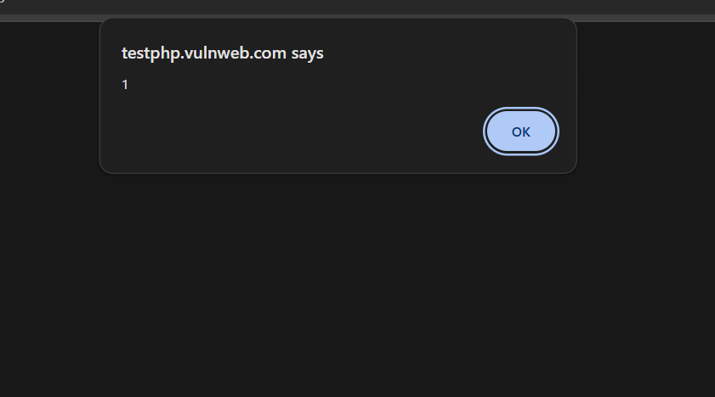

Task 7: Splunk Investigation
Outcomes – Summary of Findings
- Objective: Use Splunk to detect Exchange exploits, lateral movement, and credential dumping.
- Tools Used:
  - Splunk queries.
  - Sysmon logs.
  - Windows Event Logs.
- Key Results:
  - Splunk Query 1: Detected suspicious PowerShell execution (lateral movement).
  - Splunk Query 2: Identified credential dumping via lsass.exe access.
  - False Positives: Filtered benign events (e.g., scheduled tasks).
Conclusion – Skills & Challenges
- Skills Gained:
  - Splunk query writing for threat hunting.
  - Correlation of logs across Sysmon/Windows Events.
- Challenges Faced:
  - Noise in logs (required fine-tuning queries).
- Improvements Needed:
  - Pre-built Splunk dashboards for faster analysis.
Screenshot – Proof of Completion
- Capture 1: Splunk query and results showing malicious activity.
  - Highlight: Circle key fields (e.g., host, EventCode).
- Capture 2: Sysmon log excerpt with malicious process creation.

